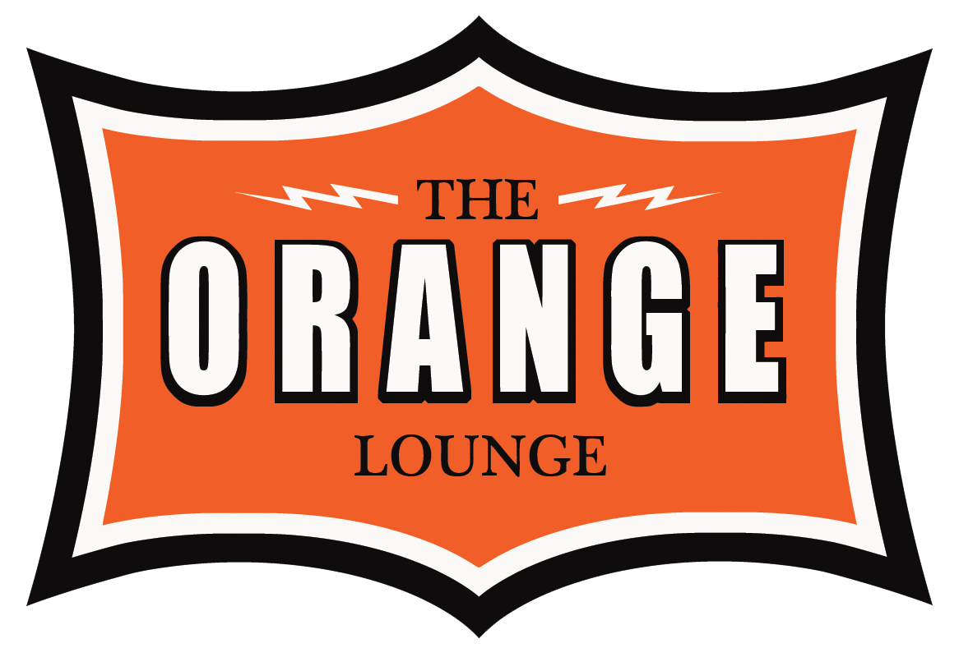

EQUIPMENT

EQUIPMENT

STUDIO A

\*\* - By request, based on availability

Console

SSL 6056E/G+ w/TR

40 BLK “E” EQ 12 BRN “E” EQ

4 Stereo Modules

G+ Computer and upgrades

Recorders /Playback

Pro Tools HD-Native

Digidesign 192 I/O w 24 inputs / 48 outputs

Lavry AD122-96 MK111

Apogee Rosetta 200

Plugins

Waves Mercury + Studio Classics

Soundtoys Version 5

Autotune 8\*\*

Melodyne\*\*

Revoice Pro\*\*

Steven Slate Trigger\*\*

Source Connect Pro\*\*

Mic Pre/EQ

Neve 31104 (3)

Class A Air modules

Neve 1079 (2)

GML 8200 stereo EQ (2)

Manley Massive Passive

Pultec EQP-1A3 (2)

Effects

AMS RMX-16

AMS-15-80s

EMT 140, 240, 251

Eventide H3500SE

Lexicon 480L

Yamaha Rev 5

Musical Instruments

Yamaha C-7 Grand Piano

Fender Rhodes w/ Speaker

Main Monitors

SOTA CF-750’s w sub

Near Field Monitors

Yamaha NS-10 w sub

Auratone 5C

Compressors/Limiters

ADR F-769 Vocal Stressor

Alan Smart C1 (1)

Alan Smart C2 (1)

DBX-160 VU (2)

Manley Variable-MU 6386

Neve 31114a (2)

Teletronix LA-3 (2)

Summit TLA-100 (1)

Vac Rac TSL-3 (2)

Retro STA Level

Microphones

AKG 414 EB (2)

AKG 451-EB w CK-1 (6)

AKG D112

Audio Technica ATM-25 (4)

Coles 4038 Ribbon (2)

Electro Voice RE20

Manley Reference Gold (Tube)

Neumann U-47 (VF-14)

Neumann U87 (3)

Neumann M149

Neumann FET 47

Neumann KM-84 (2)

Neumann M-582 (Tube) (2)

Sennheiser 421 (6)

Shure SM-58 (2)

Shure SM-57 (5)

Royer SF-12

Royer 121

DI’s

Avalon U5 (2)

 

EQUIPMENT

STUDIO B

EQUIPMENT

Console

Control 24

Recorders

Pro Tools HD-Native

Digidesign 192 I/O 8x8

Mic Pre/EQ

Neve 1073 (2)

Monitors

Dynaudio BM-15A’s

Dynaudio BM 6a

Yamaha NS-10

Auratone 5C

Plugins

Waves Mercury + Studio Classics

Soundtoys Version 5

Autotune 8\*\*

Melodyne\*\*

Revoice Pro\*\*

Steven Slate Trigger\*\*

Source Connect Pro\*\*

\*\* - By request, based on availability

STUDIO B

Compressors/Limiters

EL8-X

Summit TLA-100 (1)

Microphones

Neumann U87

Manley Reference Gold (Tube)\*\*

Neumann U-47 (VF-14)\*\*

Neumann FET 47\*\*

Neumann M149\*\*